Appendix - B

SUKKUR IBA UNIVERSITY
Department of Computer Systems Engineering



Final Year Design Project Proposal Form

Submission Date:

Project Title:
Main Subject Area/s: | Medical  Agriculture  Power Sector  IOT Robotics  Artificial Intelligence  Machine Learning   Software development  Web Development  Others
Nature of Project: |  Research, Development, and Engineering (RD&E) leading to production capability   Application oriented Research, Design & Development (R, D&D) having production potential   Basic R&D
Mapped SDG: |  No Poverty  Industry, Innovation and Infrastructure   Zero Hunger  Sustainable Cities and Communities   Good Health and Well-Being  Climate action   Clean Water and Sanitation  Partnerships   Affordable and Clean Energy  Life in Land   Decent Work and Economic growth  Reduced Inequalities   Gender Equality  Peace, Justice and Strong Institutions   Life Below Water  Responsible Consumption and Production
Students: | Name |  |  | CMS ID
Contact Information of Group Leader | Mobile No:  Email Address:
Supervisor: |  |  | Co-Supervisor (if any):
Industrial Advisor (if any): | Name:  Organisation/ Industry:  Designation:
Is this project a part of vertical integrated project? |  |  |  | Yes  | No 
If yes, please give title of previous project:
Funding availability for the project: |  |  |  | Yes  | No 
If yes, please give details from which funding agency:

Is this project targets to solve any industry/society related problem in particular? |  |  |  | Yes  | No 
If yes, please give details:

Project Overview

Briefly explain in no more than 2 pages what your project is about and what you are going to do in this project.

Aims and Objectives of Project

Write down the aims and objectives of your project.

Literature Review

If you don’t want to add literature review in the overview section above, you can give the literature review here however it should be brief.

Methodology for Implementation of Project

You have to explain that how you are planning to carry out this project. This involves explaining what kind of activities you will be doing such as literature review, experimental setup, installation of hardware/software, designing of an algorithm, Data collection, results analysis etc.

Project Plan/Gantt Chart

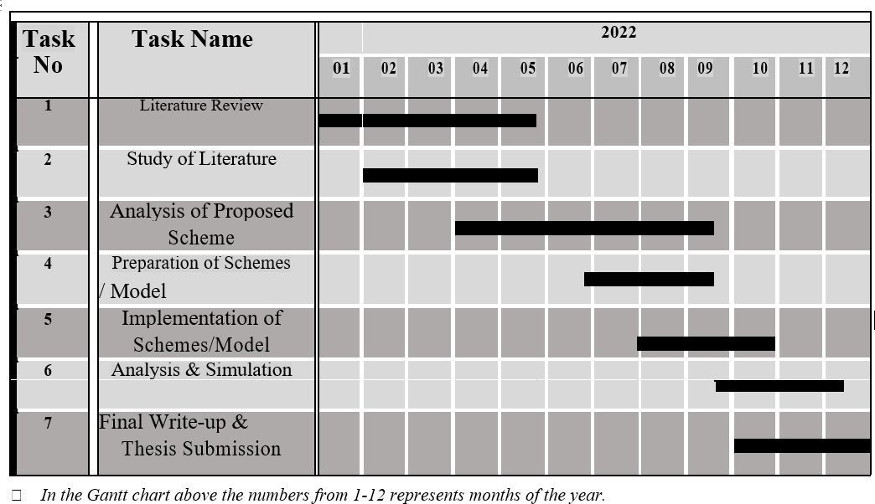
Please put the data in the Gantt chart based on your project description. Also redefine the milestones based on how you can achieve them. The things define here are just to give you an idea how to write a technical document.
Fig 3: Sample Gantt Chart
In the Sample Gantt chart given in Figure 3, the numbers from 1-12 represents months of the year.

Budget Description

Write about budget required for the proposed project here. Do mention about that how the equipment/experimental setup required will be arranged. E.g., experimental setup is present in university or some other organization’s setup will be used or funding is required for the execution of the project.
Sr. No | Item/Product | Details of Product | Source of Purchase | Quantity | Price | Total Amount

References

Includes all references: articles, media facts, books, reports, regulations, internet articles, papers that you referenced from the text. References can be written in single space with extra space between references as in the format below. There are many different ways to arrange the information and punctuation in a reference listing. The most important thing is to make sure all references are complete and that the format of your references is consistent throughout.
  - Example, S.Z. (2008). How to cite a complete journal reference. J. Complete Thesis. 1(2): 47-52.
  - Example, S.Z., Second, W.S. (2007). How to cite a complete conference proceedings paper. In: Proceedings, 2nd International meeting of Masters Students, Paper # XW15 (Potsdam NY, November, 2007).
  - If you use the “thesis” reference” style you will get the proper line spacing and indent style without further changes. Above are examples to show complete citation, other formats also acceptable.

Signature of Students:
1.

2.

Supervisor’s Comments

Name: Designation:

Signature:

FYDP Evaluator Remarks

Project Evaluator:

Name: Designation:

Signature:

Final Year Design Project Coordinator

